ESL TEXes (154) Preparation session | - get certified*  - •  - at no cost to you**
Professional Development Description  ESL TExES Preparation Session  This training focuses on the TExES English as a Second Language Supplemental (154) exam. The session is designed to provide participants with an overview of the examination including the targeted domains, the test format, and sample questions. It is encouraged for participants to bring an electronic device to enrich their learning experience.  Additional Details  - Participants can attend all sessions if desired.  - Participants will be compensated on a fixed hourly rate of $30.00  - Training sessions will be held via Microsoft TEAMS.  *certification will be determined by successfully meeting the state passing score.  **PSJA will reimburse you once you successfully pass the exam and provide proof of completion. | 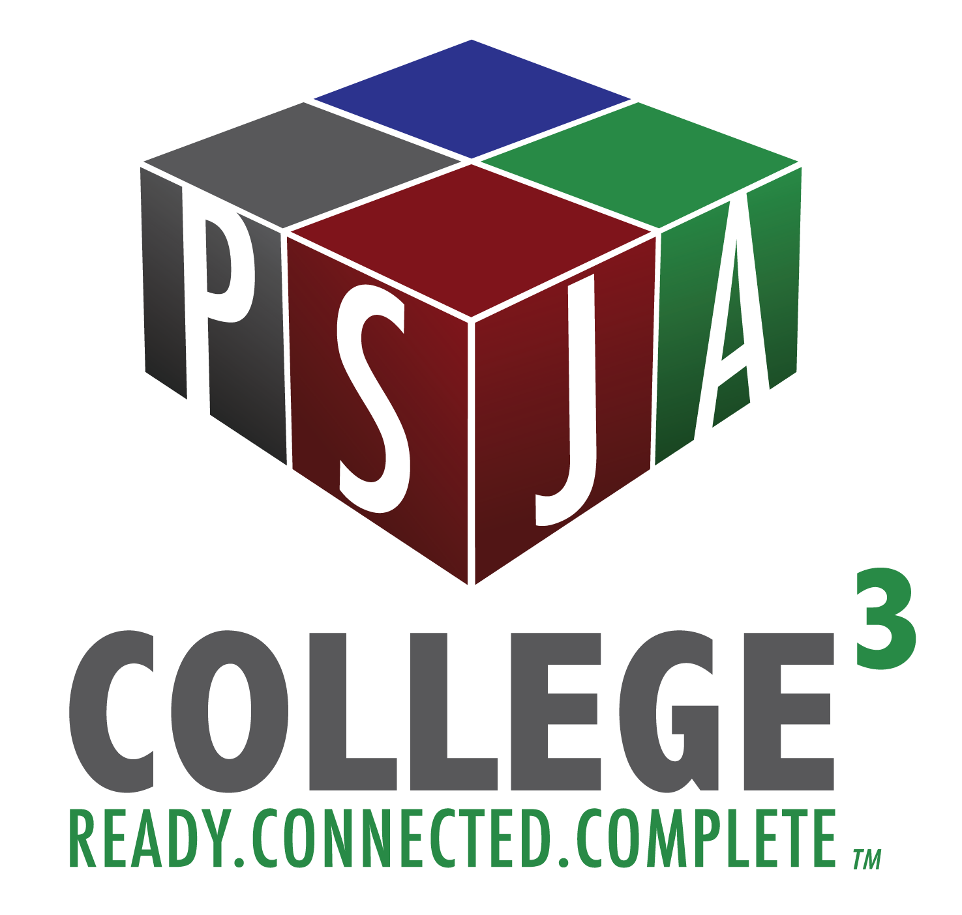  Fall 2020 Workshop Numbers:  161519  161522  161523

